


DECEMBER 2019

BAT REPORT

DOC REF: TE0330/B/A
CLIENT: Natural England
SITE NAME: St. Moran Church, Lamorran, Cornwall

BAT REPORT FINAL
Document ref: | TE0330/B/A
Client: | Natural England
Site Name: | St. Moran Church, Lamorran, Cornwall

Report produced by | Tor Ecology Ltd, Suite 8 Buckfastleigh Business Centre, 33 Chapel St, Buckfastleigh, Devon TQ11 0AB
Author(s) | Alex Leishman Grad CIEEM Bat Class Licence (Level 2)
Verified by | Jenni Reid BSc (Hons) CEnv MCIEEM | 

Issue date | December 2019
Revision | A

DECLARATIONS OF COMPLIANCE
The report which we have prepared and provided is in accordance with the Chartered Institute for Ecology and Environmental Management’s Code of Professional Conduct. We confirm that the opinions expressed are our true and professional bona fide opinions.

This report has been produced in accordance with British Standard 42020:2013 “Biodiversity, Code of practice for planning and development” and the Chartered Institute of Ecology and Environmental Management’s Guidelines for Ecological Report Writing (CIEEM, 2017).

DISCLAIMER
Tor Ecology Limited has exercised all reasonable skill and due care in preparing this report. Tor Ecology Limited has not, unless specifically stated, independently verified information provided by others. No other warranty, express or implied, is made in relation to the content of this report and Tor Ecology Limited assumes no liability for any loss resulting from errors, omissions or misrepresentation made by others.

Any recommendation, opinion or finding stated in this report is based on circumstances and facts as they existed at the time that Tor Ecology Limited performed the work (including based on the information provided by the client). Professional judgement and opinion has been utilised where required. All opinion is provided in good faith.

Nothing in this report constitutes legal advice or opinion. If legal opinion is required a qualified legal professional should be contacted for advice.

DATA VALIDITY
Please note that unless otherwise stated, the contents of this report will remain valid for a maximum period of 12 months from date of issue. Beyond this updated survey work may be required to establish any changes in baseline conditions.
NON-TECHNICAL SUMMARY
Tor Ecology Limited were commissioned by Natural England to undertake a suite of bat surveys at St. Moran Church in Lamorran, Cornwall, between May and September 2019 in order to provide comprehensive information on how roosting bats use the church. These surveys were undertaken to support the registration of the church under the Bats in Churches Class Licence (BiCCL) as part of the Bats in Churches Project, a Heritage Lottery Funded Project set-up to help reduce the impacts of roosting bats on churches and the people that use them.

This report describes the findings of the surveys carried out at St. Moran Church including a Light Touch Survey (LTS) undertaken by Tor Ecology in May 2019 and 7no. nocturnal (emergence/ re-entry) surveys undertaken between May and September 2019.

The Light Touch Survey (LTS) recorded large accumulations of Long-eared Plecotus sp. bat droppings, as well as observations of urine staining, over most surfaces within the church. One Long-eared bat was observed roosting within the nave during the survey. Scattered droppings were also observed within the porch. During a previous Light Touch Survey carried out by a Natural England Voluntary Bat Roost Visitor (VBRV) in 2017, 1no. dead juvenile Brown Long-eared Plecotus auritus bat was identified on the floor of the nave within the church, and droppings characteristic of Greater Horseshoe Rhinolophus ferrumequinum bat were recorded within the porch.

The nocturnal surveys undertaken by Tor Ecology in 2019 confirmed the presence of a Brown Long-eared maternity roost (approx. 25 individuals recorded) in addition to non-breeding day roosts for small numbers (<5no.) of Common Pipistrelle Pipistrellus pipistrellus and Soprano Pipistrelle Pipistrellus pygmaeus bats.

The large volume of droppings deposited by the colony of Brown Long-eared bats within the church is damaging fittings and furnishings and has resulted in services at the church being stopped as cleaning before each use has become unfeasible. Mitigation and management proposals have been developed in collaboration with the Parochial Church Council (PCC) representatives, appointed architect and the Diocesan Advisory Committee (DAC) and it is expected that bat roosts present within the church can be retained and that the Favourable Conservation Status of all species present can be maintained following the proposed works to bring St. Moran Church back into use. Details of the mitigation and management proposals are provided in the accompanying Bat Management Plan document.
CONTENTS
1 INTRODUCTION 1
1.1 Background and Objectives 1
1.2 Site Description and Location 1
2 METHODS 3
2.1 Desk Study 3
2.2 Field Survey 3
2.2.1 Bat in Churches Licence Methodology 3
2.2.2 Light Touch Survey 4
2.2.3 Nocturnal Emergence / Re-entry surveys 4
3 RESULTS 8
3.1 Desk Study 8
3.2 Field Survey 8
3.2.1 Light Touch Survey 8
3.2.2 Nocturnal Emergence/ Re-entry Surveys 11
4 EVALUATION AND IMPACT ASSESSMENT 20
4.1 Summary and interpretation 20
4.2 Roost characterisation and evaluation 22
4.3 Legislation and Planning Policy 23
4.4 Assessment of Potential Impacts on Bats 24
5 LICENCE REGISTRATION AND REQUIRED ACTIONS 25
6 REFERENCES 26
7 APPENDICES 27
8 COPYRIGHT 34

- INTRODUCTION
  - Background and Objectives
This document has been prepared by Tor Ecology Limited (t/a Tor Ecology) on behalf of Natural England in support of an application for registration of St. Moran Church, Lamorran, Cornwall. under the Bats in Churches Class Licence (BiCCL) scheme as part of the ‘Bats in Churches’ partnership project.

A Light Touch Survey (LTS) at St. Moran Church carried out by Natural England on 15th August 2017, and previous records of roosting bats provided by Voluntary Bat Roost Visitor (VBRV) surveys between 1999 and 2016, identified the church as a candidate for the Bats in Churches scheme.

The church has been out of use for general services since 2014 as keeping the interior of the church sufficiently clean has become unfeasible due to the large volume of droppings deposited by the resident Brown Long-eared maternity colony. The droppings and urine are also resulting in varying levels of damage to interior fittings and furnishings, primarily to wooden furnishing which are considered of ‘moderate’ heritage significance. Refer to the Statement of Significance by the heritage consultants for an assessment of the impacts on bats on the heritage of the church.

This report describes a suite of bat surveys carried out by Tor Ecology in 2019 included LTS and nocturnal bat surveys undertaken to inform the use of St. Moran Church by roosting bats and forms part of the package of supporting information for the Bats in Churches Class Licence registration. A description of the survey methods used is provided together with detailed survey findings, and outlines the registration process and further actions required.

  - Site Description and Location
The curtilage of St. Moran Church, hereinafter referred to as ‘the Site’, is centred on National Grid Reference SW 8785 4172 and is located within the small hamlet of Lamorran, Cornwall. St. Moran Church dates originally from the 13th Century and was partly rebuilt and restored in the 19th Century. Surrounding the church is a small churchyard dominated by grassland with scattered mature trees and areas of scrub on the western margin. There is a detached bell tower situated approximately 20m to the south-west of the church, in the west of the Site, and the northern boundary of the Site has a line of broadleaved trees.

The Site is accessed by a narrow minor road which encircles the eastern, southern and western boundaries of the churchyard. The surrounding landscape is dominated by broadleaved woodland and pastureland with connecting hedgerows and trees. The Site was located within the Cornwall Area of Outstanding Natural Beauty (AONB) and approximately 30m north of the Site of Special Scientific Interest (SSSI) Upper Fal Estuary and Woods and the Fal and Helford Special Area of Conservation (SAC).

- METHODS
  - Desk Study
A data search was obtained from The Environmental Records Centre for Cornwall and the Isles of Scilly (ERCCIS) in September 2019 for existing records of bats within 2km of the Site in order to provide supporting information on the distribution of bat species and known roosts in the surrounding area.

The desk study also included a search for bat records within 2km of the Site using the NBN Atlas – records licenced for commercial use (CC-BY, CC0 and OGL licenced data) (www.nbnatlas.org), and records of European Protected Species licences relating to bats were identified using the MAGIC interactive map tool (www.magic.gov.uk).

The findings of the desk study are provided in Section 3.1.

  - Field Survey
    - Bat in Churches Licence Methodology
The suite of bat surveys carried out at Lamorran Church were undertaken in accordance with the Bats in Churches Class Licence methodology, set-out as follows with further details on the methodology followed for each component of the surveys detailed in the subsequent sections:
- One thorough physical inspection (Light Touch Survey) must be undertaken.
- The surveys must represent at least one full active season.
- Surveys should be undertaken in the optimum period for bats between May-August (as per the Bat Conservation Trust Good Practice Guidelines).
- The surveys should comprise at least four surveys, comprising three dusk surveys and one dawn survey.
- At least one dusk activity survey must be undertaken during each of the following periods with each survey being conducted at least two weeks apart:
a) May to mid-June
b) Mid-June to end July and;
c) August to mid-September.
- The dawn survey must be conducted between May to mid-June and may be timed to take place directly after an emergence survey.
- One surveyor must be present inside the building during a dawn survey to identify internal access points.

    - Light Touch Survey
A Light Touch Survey (LTS) was undertaken by Tor Ecology on 17th May 2019. The church was inspected both externally and internally in accordance with best practice guidance (Collins, 2016) to search for bats, signs of their presence including droppings, staining, urine stains and feeding remains, and potential roosting features and access points. All suitable roosting features and signs of bats were recorded onto a base map.

The LTS was undertaken by Jenni Reid CEnv MCIEEM (Natural England Bat Licence Number 2015-115427-CLS-CLS Level 2), a registered consultant for the Bats in Churches Class Licence. The inspection was undertaken using an endoscope, high-powered torch, headtorch, camera, binoculars and ladder.

A further inspection was carried out on the 10th of September 2019 by Jenni Reid and Alex Leishman using a scaffold tower, ladder, torches and endoscope to help establish access routes within the roof void between different areas of the church and to further investigate the main access points identified during the previous surveys.

The bat droppings observed within the building were identified as being those from Long-eared bats. Grey Long-eared bats are currently confirmed as being present within the counties of Sussex, Hampshire, the Isle of Wight, Dorset, Devon and Somerset. Due to the absence of records of Grey Long-eared bats within Cornwall, the droppings observed within the building were determined to be those of Brown Long-eared bats. Therefore, it was not considered to be necessary to conduct DNA analysis of the bat droppings located within the building.

    - Nocturnal Emergence / Re-entry surveys
The dates and weather conditions for each of the survey visits are displayed in Table 1 below.

Table 1: Dates and weather conditions of survey visits
Survey | Date and time | Weather conditions | Surveyors³
Visit 1  [Dusk]  Sunset: 21:03 | 20/05/19  20:40 – 23:03 | Temp: 16.0°C – 9.5°C  Wind¹: 0  Cloud²: 0/8  Rain: 0 | Internal: JR  External: JW, LS, TB
Visit 2  [Dusk]  Sunset: 21:30 | 11/06/19  21:00 – 23:00 | Temp: 13.0°C–12.0°C  Wind¹: 2-3  Cloud²: 8/8  Rain: 0 | Internal: JR  External: LS, TB, KN
Visit 3  [Dusk]  Sunset: 21:23 | 16/07/19  21:15 – 22:56 | Temp: 18.7°C–16.2°C  Wind¹: 0-1  Cloud²: 1/8  Rain: 0 | Internal: JR  External: LS, TB, MN
Visit 4  [Dawn]  Sunrise: 5:28 | 17/07/19  03:58 – 05:37 | Temp: 16.0°C – 15.4°C  Wind¹: 0  Cloud²: 1/8  Rain: 0 | Internal: JR, AL, LS  External: TB, MN
Visit 5  [Dusk]  Sunset: 20:57 | 05/08/19  20:55 – 22:33 | Temp: 19.0°C – 17.0°C  Wind¹: 0  Cloud²: 7/8  Rain: 0 | Internal: AL, LS, TB  External: N/A
Visit 6  [Dusk]  Sunset: 19:46 | 10/09/19  19:31 – 20:46 | Temp:15.2°C – 12.0°C  Wind¹: 0  Cloud²: 3/8  Rain: 0 | Internal: JR, AL  External: LS, KN
Visit 7  [Dawn]  Sunrise: 06:47 | 11/0919  05:18 – 06:49 | Temp: 15.5°C – 16.0°C  Wind¹: 0-2  Cloud²: 8/8  Rain: 0 | Internal: JR, AL  External: LS, KN
1: Wind as per Beaufort scale
2: Cloud cover given in Oktas (/8)
3: Surveyors: JR – Jenni Reid; JW - Jenny Wytcherley; AL - Alex Leishman; LS - Laura Snell; TB - Tamsyn Bridger; MN - Maddison Nixon; KN - Ken Neal.

Nocturnal Survey Methodology
Dusk emergence surveys commenced 15 minutes before sunset and continued until 1.5 hours after sunset. Dawn re-entry surveys commenced 1.5 hours before sunrise and continued until 15 minutes after sunrise (as per the Bat Conservation Trust Good Practice Guidelines).

An iterative process was followed for the nocturnal surveys to gain the most complete picture of bat numbers, roost locations, access points and perches. To achieve this, the survey methodology was adapted through varying surveyor positions within the internal area if the church and externally to view the external elevations of the building during each visit. To summarise:
- On three of the nocturnal survey visits (20/05/2019, 11/06/2019 and 16/07/2019), three surveyors were positioned around the building externally to ensure that all potential roosting features could be observed during the survey effort, and one surveyor was positioned inside the building throughout the survey to identify internal access and roosting points.
- On the nocturnal survey visits (17/07/2019, 10/09/2019 and 11/09/2019), two surveyors were positioned around the building externally and two surveyors were positioned inside the building
- On one Site visit (05/08/2019), four surveyors were positioned inside the building throughout the survey to identify internal access and roosting points.

Surveyors used Wildlife Acoustic EM3+ or EM2 Touch full-spectrum bat detectors, except for an individual Anabat Express detector being used on the 10-11/09/2019 surveys when the detector was left within the church between the surveys to record activity throughout the night. Bat calls were identified to species level (where possible) in the field and were recorded for later analysis using call analysis software (Kaleidoscope Viewer and Analook). Where directly observed all access and egress points were noted during surveys, as were incidental results (i.e. foraging and / or commuting activity), with flight lines recorded onto base maps in the field.

On each survey visit, up to 3no. infrared video cameras in combination with infrared lamps were used within the church to aid visibility and were either hand-held or positioned to focus on identified roosts and access points. Positions of surveyors and cameras were varied over the surveys to gain the best overall picture of how bats use different areas of the church. Videos were recorded to enable later viewing to confirm observations made during the surveys.

    - Surveyors
The nocturnal surveys were undertaken by the following surveyors:
- Jenni Reid CEnv MCIEEM (Natural England Bat Licence 2015-115427-CLS-CLS Level 2, Bats in Churches Class Licence, Bat Low Impact Class Licence)
- Jenny Wytcherley (Natural England Bat Licence 2015-12211-CLS-CLS Level 2)
- Alex Leishman Grad CIEEM (Natural England Bat Licence 2017-29436-CLS-CLS Level 2)
- Laura Snell MCIEEM
- Tamsyn Bridger ACIEEM
- Maddison Nixon Student CIEEM
- Dr Ken Neal

    - Constraints
It is not considered that there were any significant constraints to the surveys.

It is not always possible to identify bats to species level, particularly in cases where the recordings taken in the field are quiet or obscured by background noise. In these cases, bats will be identified to genus level where possible (e.g. Myotis sp., Pipistrellus sp.), or listed as ‘unidentified’ in the results section.

- RESULTS
  - Desk Study
A data search was obtained from The Environmental Records Centre for Cornwall and the Isles of Scilly (ERCCIS) in September 2019 for bat species records within 2km of the Site. The data search returned 22 bat species records between 1966 and 2018, comprising 9no. records for unidentified bats Chiroptera (including one record for 12no. bats and one record for 2no. bats), 6no. records for Common Pipistrelle (including two records for 4no. bats), two records for Long-eared bats (both records 4no. bats), two records for Brown Long-eared bats, one record for 2no. Greater Horseshoe bats and two records for Lesser Horseshoe bats (including one record for 2no. bats).

The NBN Atlas desk study returned six records of bat species within 2km of the Site between 1965 and 2016. These comprised two records for Greater Horseshoe bats (including 1no. maternity roost), two records for Lesser Horseshoe bats and two records for Common Pipistrelles.

  - Field Survey
    - Light Touch Survey
Building description
The building is a small medieval church in a cruciform shape, with the chancel at the eastern end, nave in the west; and northern and southern transepts with further seating on each side of the main aisle. The walls are constructed of solid stone and it has a tall pitched roof covered with slates and clay ridge tiles. The roof has gable ends with parapet gables lined on top by coping stones. There is a small porch of the same construction located in the corner between the nave and south transept.

Internally, the church has one large void, with the exception of the porch which is separated by a large wooden door and has no secondary external door. The inside walls of the church are rendered and the roof is lined with slatted wooden boarding. Within the chancel, nave and the crossing, the upper section of the wooden clad ceiling does not meet the apex of the roof and therefore creates a triangular void between the panelling and roof slates (approx. 1m wide and 1m to 2m high). There is no such void in the north and south transepts, however, as far as could be ascertained with the use of an endoscope there is a consistent gap between the ceiling panelling and the slates (approx. 20cm) where bats can roost and move between access points.

Bat roosting features and evidence – Internal
Internally, there is a large abundance of bat droppings, characteristic of long-eared bats, of various ages present over the floor and furnishings of the church which indicates regular use of the internal area of the church by a sizable colony of Brown Long-eared bats. The main accumulations of bat droppings are present on the floor of the south transept; around the alter at the base of the chancel gable end wall; and beneath the stone arch separating the north transept from the crossing.

In the south transept there are large accumulations (1000s) of bat droppings of varying ages, including many fresh, along the base of the gable end wall; areas approximately beneath the central ridge line of the roof, and beneath the southern side of the arch between the south transept and the crossing. The rafter and collar tie adjoining the gable end wall have suitable gaps for bats to access running the length of the timbers, allowing direct access into the church and between the ceiling panelling and slates. Along the gable end wall, droppings were also observed affixed to the wall and in cobwebs where a gap is present between the wall and the collar tie (100s) and on the windowsill directly below this area (1000s). Urine staining was observed on the organ, alter, pews and masonry. There is also a gap along both sides of the ridge beam allowing access between ceiling panelling and slates.

Large accumulations of bat droppings were identified on the floor of the chancel and on the alter at the base of the eastern gable end wall, as well as scattered over the gable end wall. Similar to the south transept, there is a gap between the roof timbers and the gable end wall with a large accumulation of droppings beneath one particular point where there is considered likely to be an access point into the gap between the panelling and slates. There are gaps on the lower sections of the timber panelling on the southern and northern aspect of the chancel which were identified as providing potential access points into the church or roost locations. Along the eaves there are small boxed-in triangular voids between the panelling and the slates which span the depth of the walls.

Large accumulations of bat droppings were identified on pews within the nave, particularly towards the south-western end and the north-eastern end. Droppings were otherwise scattered throughout this area (100s). Gaps, including one approximately 15cm x 1cm, were identified in the ceiling timbers adjacent to the western gable end wall, which could provide roosting opportunities or access into the church for bats.

In the northern area of the crossing, adjacent to the stone arch leading into the north transept is a large accumulation of droppings on the floor of the church (1000s). One long-eared bat (as identified from a ground-level visual inspection) was observed roosting on the ceiling panelling in this location. A gap is also present between the ceiling panelling in the northern transept and stone arch near this location which was identified as a potential roosting site.

Fewer bat droppings were identified within the remainder of the north transept than elsewhere within the church; a moderate scattering over the floor and pews, and occasionally on walls and window ledges. Gaps were noted in the timber ceiling, including a large gap at the southern end of the western aspect on the lower section of the panelling, which could provide access into the church from the eaves.

Scattered bat droppings of an unidentified species were also recorded within the porch of the church, affixed to the walls. These are thought to be indicative of a night roost due to their location. There are also gaps of approximately 3cm x 3cm, which could provide access for roosting bats between the ceiling panelling and slates within the porch.

Bat roosting features and evidence – External
Externally, a number of gaps are present between the wall and roof at the eaves on most aspects of the church which could provide access into the cavities between the ceiling panelling and roof slates, and access into the internal areas of the church from there. Bird nesting material was recorded in some of these features, generally associated with the northern transept and northern-facing walls. Nesting material identified to be that of Jackdaw Corvus monedula was observed in some of these areas, which would likely discourage use of these areas by bats. The areas considered to have the greatest level of potential for bats to access the church were along the eastern elevation of the south transept and southern elevation of the chancel.

Gaps were identified between the coping stones and the tops of walls on the gable end of the south transept. Two of these were checked with an endoscope and appeared to lead into the void between the ceiling panelling and roof slates inside the church. From this area bats are likely to be able to access the main area inside the church from gaps recorded internally.

A missing pane of glass in the window on the gable end of the northern transept could allow direct access into the interior area of the church for bats.

Other survey data
Survey data collected from a previous inspection of the church by VBRVs in August 2017 showed records of a Greater Horseshoe droppings (approx. 50) within the porch, suggesting presence of a night roost for this species. During this visit, a dead juvenile Brown Long-eared bat was recorded on the floor of the nave along with large numbers (100s) of long-eared droppings throughout the church. Roosts for Greater Horseshoe and Lesser Horseshoe bats were also recorded in association with the bell tower in the west of the Site.

    - Nocturnal Emergence/ Re-entry Surveys
The results of each nocturnal bat survey visit are summarised in the sections below, including details of bat species recorded, emergence/re-entry locations and an estimate of total bat numbers likely to have been recorded during each survey. Key locations, including identified roosting sites, access points and perches, referenced are shown on the Bat Roost Access Location Plan in Appendix I and photos of these features are provided in Appendix II.

Visit 1: 20/05/19 Dusk (Sunset - 21:03)
Total roosting bats recorded: Up to 25no. Brown Long-eared; 2no. Common Pipistrelle; 1no. Soprano Pipistrelle and 1no. pipistrelle Pipistrellus sp.

Brown Long-eared
The first Brown Long-eared bat was recorded at 21:12, emerging from the eaves at the south-eastern corner of the chancel (Point H). A second was recorded emerging from a gap beneath the coping stones near the south-western corner of the south transept gable end at 21:13 (Point A).

Internally, the first Brown Long-eared bat was recorded at 21:19 flying high around the inside of the roof. From this time around 5no. bats were regularly recorded flying around the inside of the church at any one time, mostly around the southern transept and chancel.

A third emergence was recorded at 21:40 from the under a tile low down along the roof gulley between the nave and south transept (Point F). At 22:25 there was a possible re-entry back into the church possibly at around this location. Fourth and fifth emergences were recorded at 22:36 and 22:48 from the same roof gully (Point A) and southern gable end (Point F) access points. At 22:40, there were between 10no. and 20no. Brown Long-eared bats perched together under the apex of the south transept.

Roosting locations within the church were not identified during this visit. The maximum estimate of the total number of Brown Long-eared bats that are likely to have been recorded during the visit is 25, calculated as a sum of bats that emerged outside and those that were remaining in the church at 22:40.

Common Pipistrelle
First Common Pipistrelle recorded briefly inside the church at 21:23, then just after this time an emergence was recorded from the eaves near the southern end of the eastern aspect of the south transept (Point C). A second bat was recorded flying within the church at 21:44 but was not recorded emerging out of the building.

Soprano Pipistrelle
1no. Soprano Pipistrelle bat emerged at 20:50 from under a tile low down along the roof gulley between the nave and south transept (Point F).

Pipistrelle sp.
1no. non-echolocating Pipistrelle bat emerged at 20:53 from same place as earlier Soprano Pipistrelle, from under a tile low down along the roof gulley between the chancel and south transept (Point F).

Other activity
Incidental bat activity observed throughout the survey included Common Pipistrelle foraging behaviour, Nyctalus sp. foraging and commuting behaviour in addition to a Greater Horseshoe bat Rhinolophus ferrumequinum commuting pass along the northern aspect of the building in an easterly direction. Myotis sp. bat passes were also identified.

Visit 2: 11/06/19 Dusk (Sunset - 21:30)
Total roosting bats recorded: 11no. Brown Long-eared, 3no. Common Pipistrelle, 1no. pipistrelle Pipistrellus sp.

Brown Long-eared
The first Brown Long-eared bat was recorded at 21:05, emerging into the main internal area of the church from the gap between the rafter and gable end wall of the southern transept (Point J). 2-3no. more bats were recorded emerging from this location between this time and 21:48.
Externally, the first Brown Long-eared recorded emerged from the eaves of the chancel (Point G) at 21:52. 4no. bats were then recorded emerging from the roof gulley between the chancel and south transept (Point F) between 22:00 and 22:12.

Between 5no. and 6no. Brown Long-eared, thought to be juveniles, were left perching under the roof apex of the south transept throughout the remainder of the survey visit.

The maximum estimate of the total number of Brown Long-eared bats that are likely to have been recorded during this visit is 11, calculated as a sum of bats that emerged outside and those that were remaining in the church thereafter.

Common Pipistrelle
The first Common Pipistrelle recorded emerged at 21:12 from the eaves (between the top of the wall and roof slates) along the eastern aspect of the south transept flying (Point E), with a second bat of this species emerging from the same place at 21:20. A single Common Pipistrelle was also recorded flying within the church between 21:53 and 22:03 but was not recorded emerging out of the building.

Pipistrelle sp.
1no. non-echolocating pipistrelle bat was recorded at 21:02 emerging from the eaves at the south-eastern corner of the chancel (Point H).

Other activity
Incidental bat activity outside the church included multiple passes by Pipistrelle Pipistrellus sp. bats along the road adjacent to the Church. Other bat species observed included Soprano Pipistrelle, Lesser Horseshoe, Greater Horseshoe, Barbastelle Barbastella barbastellus and Noctule Nyctalus noctula.

Visit 3: 16/07/19 Dusk (Sunset - 21:23)
Total roosting bats recorded: Up to 22no. Brown Long-eared; 2no. Common Pipistrelle, 2no. Soprano Pipistrelle; 1no. pipistrelle Pipistrellus sp.

Brown Long-eared
Internally, Brown Long-eared bats were observed emerging from roosts behind the wooden ceiling panelling from 21:38, specifically from:
- A gap in the lower panelling just above the north-facing wall near the north-eastern corner of the chancel (Point K); and
- The top of the ceiling adjacent to (just on the northern side of) the stone arch between the south transept and the crossing (Point L).

Low numbers of bats were then seen to exit from the interior of the church into gaps in the panelling at the level of the eaves above the southern wall of the chancel (Point M) and above the eastern wall of the south transept (Point N), probably before exiting the building. 18no. Brown Long-eared bats were recorded emerging between 21:38 and 22:35 from the building from three corresponding external features:
- 9no. bats from above the wall along the roof gulley between the chancel and south transept (Point F); and
- 5no. and 3no. bats from Points C and D respectively, along the roof eaves above the eastern wall of the south transept.

From 22:40, up to 5no. bats were recorded flying between roosts and perches within the church at Points K and L, and beneath the panelling in the crossing adjacent to the stone arch leading into the north transept (Point P)

The maximum estimate of the total number of Brown Long-eared bats that are likely to have been recorded during this visit is 22, calculated as a sum of bats that emerged outside and those that were remaining in the church thereafter.

Common Pipistrelle
1no. Common Pipistrelle bat emerged at 21:15 from under a tile low down along the roof gulley between the chancel and south transept (Point F). 1no. Common Pipistrelle emerged from the building from the roof eaves near the south-eastern corner of the south transept (Point C) at 21:36.

Soprano Pipistrelle
Internally, 2no. Soprano Pipistrelle bats were observed flying within the building at 21:20. Two confirmed Soprano Pipistrelle bats emerged from the building from two locations along the roof eaves near the south-eastern corner of the south transept at 21:29 (Point B) and 21:34 (Point C).

Pipistrelle sp.
1no. probable non-echolocating pipistrelle bat was recorded at 21:04 emerging from the eaves at the south-eastern corner of the chancel (Point H).

Other activity
Incidental bat activity was observed with species including Common Pipistrelle, Soprano Pipistrelle, Nyctalus sp., Myotis sp. and Greater Horseshoe bat.

Visit 4: 17/07/19 Dawn (Sunrise – 05:28)
Total roosting bats recorded: Up to 21no. Brown Long-eared; 3-4no. Soprano Pipistrelle.

Brown Long-eared
Externally, approximately 20-21no. Brown Long-eared bats were first recorded re-entering the building between 04:45 and 05:28 at three locations:
- Approx. 19no. bats re-entered above the southern wall of the cancel close to the roof gulley (Point G);
- 1no. bat re-entered at the roof eaves above the east-facing wall close to the south-eastern corner of the south transept (Point B); and
- 1no. possible Brown Long-eared re-entered at the roof eaves above the south-facing wall close to the south-eastern corner of the chancel (Point H).

Internally, mirroring re-entries observed outside the building, a number of Brown Long-eared bats (15+) were recorded entering the building from a gap in the wooden panelling at eaves level above the southern wall of the chancel (Point M). A further 2-3no. bats were recorded entering the main internal area from the gap between the cross tie, rafter and gable end wall of the south transept (Point J), and a single Brown Long-eared re-entered via a gap in the panelling at eaves level near the south-eastern corner of the south transept (Point N).

After entering the main internal area of the church, the bats were then flying over towards the northern transept where they were perching under the ceiling panelling and then taking off to fly around just beneath the ceiling of the building before returning. Between 04:40 and around 05:15, between 15 and 20no. Brown Long-eared bats were observed entering a roost from the north transept into a gap at the apex of the roof adjacent to the stone arch between the north transept and the crossing (Point Q).

Soprano Pipistrelle
Around 3-4no. Soprano Pipistrelle bats were considered to have re-entered the building from the outside between 04:58 and 05:32 around the main access point used by the Brown Long-eared bats; around the eaves of the southern wall of the chancel (Point G) and along the lower section of the adjacent roof gulley (Point F).

Visit 5: 05/08/19 Dusk (Sunset – 20:57)
Total roosting bats recorded: Up to 20no. Brown Long-eared; 1no. Soprano Pipistrelle.

Brown Long-eared
Brown Long-eared bats were recorded flying around the internal area of the church shortly after the start of the survey before sunset. Up to four confirmed or potential roost access points were observed within areas of the ceiling panelling, including:
- 5-7no. bats from the southern side of the stone arch between the north transept and the crossing (Point P). It is considered that this roost is likely to link up to the roost access point at Point Q;
- 1-2no. possible emergences from gaps in the ceiling panelling at the highest points of the chancel roof (Point R);
- 6no. emergence from a gap in the panelling near a light fitting from the void above the nave (Point S); and
- Possible emergence of 1no. bat from a gap in the panelling adjacent to the western gable end wall from the void above the nave (Point T).

After bats were seen emerging from roosts, 12no. were seen to enter the gap in the panelling at eaves level above the south-facing wall of the chancel (Point M) and it is assumed they emerged from the building outside after this. A further 3-4no. bats were observed re-entering back into the gap in panelling at the top of the western gable end (Point T) and it is considered possible that they exited the building from the access point from this location.

At the end of the survey, a small number of bats remained perching in various areas of the church including beneath the apex of the north transept (2-3no. bats) and 1no. close to the western gable end wall. The maximum estimate of the total number of Brown Long-eared bats that are likely to have been recorded during this visit is 22, calculated as a sum of bats that entered areas of panelling close to expected exit points and those that were remaining in the church thereafter.

Soprano Pipistrelle
An individual Soprano Pipistrelle bat was observed flying within the church around sunset.

Visit 6: 10/09/19 Dusk (Sunset – 19:45)
Total roosting bats recorded: 2-3no. Brown Long-eared; 1no. Soprano Pipistrelle; 1no. Common Pipistrelle.

Brown Long-eared
At 20:05, 2no. probable emergences into the internal area of the church were recorded from gaps in ceiling panelling at the western gable end wall (Point T). A single bat was observed entering the gap in the wooden boarding just above the south-facing wall of the chancel (Point M).

Common Pipistrelle
An individual Common Pipistrelle bat was heard flying within the church at 19:48-49 was not observed emerging from the building outside. Common Pipistrelle activity was recorded within the church by the static detector from 18:48.

Soprano Pipistrelle
An individual Soprano Pipistrelle bat was observed emerging from the eaves above the west-facing wall of the northern transept (Point I) at 19:48.

Other activity
Other species recorded outside of the church during the survey included Common Pipistrelle, Soprano Pipistrelle, Noctule, Greater Horseshoe, Lesser Horseshoe and Myotis sp.

Visit 7: 11/09/19 Dawn (Sunrise – 06:49)
Total roosting bats recorded: At least 3no. Brown Long-eared. Possible Lesser Horseshoe (in porch).

Brown Long-eared
1no. Brown Long-eared bat was observed entering a gap in the ceiling panelling adjacent to the western gable end of the nave (Point T). In total 3no. bats were seen at any one time between 5:38 and 6:52 repeatedly entering and emerging again from this feature, two of which entered the church from different locations. It is possible that the third, which in the first instance was observed emerging from this gap could have entered the church from an external access point linked to this void above the panelling close to the western gable end. 1no. Brown Long-eared bat was observed landing on and then flying away from the southern aspect of the roof of the nave adjacent to the coping stones on the western gable end. Although it was not observed entering the roof, this could indicate the presence of a roost access point close to this location.

Lesser Horseshoe
1no. Lesser Horseshoe bat was observed flying inside the church at the beginning of the survey (05:18) but promptly exited when the main door was re-opened and flew in the direction of the bell tower. It is expected that the bat flew into the church when the door was first opened at the beginning of the survey and would not normally use the church, which is supported by the bat call data collected from the static detector left in the church overnight. However, it is possible that this bat could have been perching within the porch when it flew in through the door.

Unconfirmed species
At 6:40 an unidentified bat was observed flying into the porch and then fly out again on closer inspection. The bat was not picked up by the bat detector used by the surveyor at this location so species could not be determined. It is possible that it could have been a Lesser Horseshoe bat as recorded within the church, earlier on during the survey.

Other activity
Incidental bat activity recorded outside during the survey included Common Pipistrelle, Soprano Pipistrelle, Greater Horseshoe and Lesser Horseshoe activity. Throughout the survey 3-4no. Brown Long-eared bats were observed flying around the churchyard emitting social calls up until approximately 30 minutes before to sunrise. Species recorded internally by the static detector over the whole of the night included Common Pipistrelle and Brown Long-eared with a short period of Lesser Horseshoe activity when it flew into the church at the beginning of the dawn survey.

- EVALUATION AND IMPACT ASSESSMENT
  - Summary and interpretation
A summary of the survey findings and discussion on interpretation of the data are provided below for each species recording roosting within the church.

Brown Long-eared
The Light Touch Survey recorded a large accumulation of droppings within the interior of the church, indicating use of the main internal space over a prolonged period by a substantial number of Brown Long-eared bats. Nocturnal surveys identified that the church is in use by maternity colony of this species, with up to 20-25no. bats regularly recorded over the summer months including young bats which often remained perched inside the church whilst others left to forage outside.

Daytime roosts identified within the church are associated with the wooden ceiling panelling (sarking) lining the inside of the roof and behind rafters and cross ties abutting the south- and east-facing gable ends. The bats were found to move around between different locations over the season. Key roost locations and internal access points include:
- Between the wall and the cross tie/rafters on the gable end of the south transept (Point J). The presence of a relatively large accumulation of droppings here suggests this is one of the most used roosts and access points. Roosts may be located behind the roof timbers and within adjacent areas of the ceiling panelling;
- Gaps in panelling at top of the ceiling adjacent to (just on the northern side of) the stone arch between south transept and the crossing (Point L); and
- Gaps in/ at the edge of the ceiling panelling on both sides of the stone arch between the north transept and the crossing (Point P and Q). It is considered likely that these two access points link up and that the roost spans the area over the top of the stone arch.

Other day roost locations for lower numbers of Brown Long-eared bats also occur within:
- A gap in the lower section of the wooden ceiling panelling just above the north-facing wall near the north-eastern corner of the chancel (Point K);
- Gaps in the top ceiling panelling at the highest point of the chancel roof (Point R) which leads into the ceiling void above; and
- The ceiling void above the western area of the nave with access points through the ceiling panelling close to a light fitting (Point S) and next to the western gable end wall (Point T).

The main access points from the internal void to points that Brown Long-eared bats use to exit the church are located along the southern elevations of the chancel and southern and eastern elevations of the south transept:
- The large gap in the panelling at the level of the eaves above the southern wall of the chancel (Point M) appears to link directly with adjacent exit points around the roof eaves (Point F) and gulley between the south transept and chancel (Point G)
- Gaps under the rafters and cross tie on the south-facing gable (Point J), and gaps in panelling just above the wall in the south-eastern corner of the south transept (Point N), link up to exit points on the external elevations along the eaves of the eastern wall (Points B, C & D) and beneath the gable end coping stones near the south-western corner of the southern wall (Point A).
- It is also possible that exit points from the church are present close to the western gable end in the nave, accessible via the adjacent ceiling void (Points S and T). There may also be other internal access points in south-eastern corner of the chancel linking to the roof eaves at Point H.

Brown Long-eared bats were regularly recorded perching beneath the ceiling panelling, with many remaining perched inside the church throughout the dusk survey visit whilst others left to forage outside. These are considered likely to include pups. Much of the church was used by perching bats during the surveys, but key areas observed included under the ridge timbers of the north and south transepts, close to gaps in the panelling beneath the ceiling voids over the chancel and nave (Points R, S & T) and close to identified roosts associated with stone arches either side of the crossing (Points L & P)

Common Pipistrelle
Up to 3no. Common Pipistrelle bats were recorded roosting within the church during any one survey visit, occasionally being detected flying within the church. Most emergences externally were observed from the eastern eaves of the south transept (Points C & E) with one bat recorded from the eaves at the roof gulley between the south transept and chancel (Point F).

Soprano Pipistrelle
Up to 4no. Soprano Pipistrelle bats were recorded roosting within the church during any one survey visit. Most emergences externally were observed from the eastern eaves of the south transept (Points B & C) and the southern eaves of the chancel (Points F and G). One bat was recorded emerging from the western eaves of the north transept during Visit 6 (Point I).

Pipistrellus sp.
Individual pipistrelle bats of an unconfirmed species (Common or Soprano Pipistrelle) were recorded one the 1st, 2nd and 3rd survey visits; emerging from the roof gulley between the south transept and chancel (Point F) and the eaves close to the south-eastern corner of the chancel (Point H).

Horseshoe bats (Lesser and Greater)
It is possible that a Lesser Horseshoe bat was observed briefly roosting within the porch close to the end of Visit 7 (dawn survey), although this is unconfirmed. General Lesser Horseshoe and Greater Horseshoe bat activity was detected during the nocturnal survey visits and both these species are known to roost within the bell tower in the west of the Site. Greater Horseshoe droppings (around 50no.) were recorded within the porch by Natural England during the initial Light Touch Survey in 2017 suggesting this is occasionally used as a night roost for this species.

  - Roost characterisation and evaluation
Based on the findings of the suite of surveys, it is considered that the church supports a maternity roost of Brown Long-eared bats, day roosts for small numbers of non-breeding Common Pipistrelle and Soprano Pipistrelle bats and a probable occasional night roost for individual/ low numbers of Lesser Horseshoe bats within the porch.

Wray et al. (2010) evaluate the scarcity of bat species within England categorising each species as common, rarer or rarest. Brown Long-eared, Common Pipistrelle and Soprano Pipistrelle bats are categorised as “common” species (i.e. are present within England in populations of over 100,000 individuals).

Evaluation methodology from Wray et al. (2010) allows for the evaluation of roosts within a geographic context. Roosts identified at the Site have been assigned a geographic value based on this, the results of which are displayed in Table 2 below.

Table 2: Assessment of Bat Roost Value
Roost type | Roost value
Brown Long-eared (common species) - maternity roost. | County Value
Common Pipistrelle (common species) day roost, small numbers (<5no.) of non-breeding bats. | Local Value
Soprano Pipistrelle (common species) day roost, small numbers (<5no.) of non-breeding bats. | Local Value
Greater Horseshoe (rarest species) - night roost (in porch) | County Value
Lesser Horseshoe (rarer species) - night roost (in porch) | County Value

  - Legislation and Planning Policy
All bats are afforded full protection under UK and European Legislation including the Wildlife and Countryside Act 1981 (as amended) and the Conservation of Habitats and Species Regulations 2017. Together, this legislation makes it illegal to:
- Intentionally or deliberately take, kill or injure a bat;
- Damage, destroy or obstruct access to bat roosts;
- Deliberately disturb bats.

Due to this protection and their status as a European Protected Species (EPS) it is necessary to obtain a licence from Natural England for any development works which will impact on individual bats or their roosts, either by destruction, modification or disturbance. It is also necessary for individuals to hold a class licence from Natural England in order to disturb or handle bats.

  - Assessment of Potential Impacts on Bats
St. Moran Church has been out of use for general services since 2014 as keeping the interior of the church sufficiently clean has become unfeasible due to the large volume of droppings deposited by the resident Brown Long-eared maternity colony. It is proposed to bring the church back into use, which will require the roosting bats to be isolated from the interior area of the building.

As a maternity colony of Brown Long-eared bats, a ‘void dwelling’ bat species, are known to be using the internal area of the church for light sampling before emerging from the building to forage and for flight practice by young pups, any works to the building have the potential to result in destruction or modification of roost sites, perches and flight areas, and to interrupt access into the roosts.

It is considered that suitable opportunities for the Brown Long-eared maternity colony roosting within St. Moran Church can be maintained through appropriate mitigation design, which is proposed to include new false ceilings within the transepts with suitable flight areas above these ceilings and to retain roost sites and perches within the existing wooden ceiling panelling with access to external emergence/ re-entry features. Full details of the mitigation and management proposals are provided in the accompanying Management Plan document.

In turn, identified roosts for crevice dwelling bat species within the church (i.e. Common Pipistrelle and Soprano Pipistrelle bats) can be retained around the eaves of the building, and between the existing ceiling panelling and roof slates.

The above works, that would otherwise result in offences being committed under wildlife legislation relating to bats, will be permitted through the registration of the Site under the Bats in Churches Class Licence (BiCCL) subject to the approval of the proposed mitigation measures by Natural England. These mitigation proposals are detailed in the Bat Management Plan document in Appendix III, along with appropriate measures to be implemented to minimise disturbance and risk of harm to bats during works.

In view of the proposals, which will affect the interior of the church and leave the porch unchanged, no impacts on roosting Lesser Horseshoe or Greater Horseshoe are expected.

- LICENCE REGISTRATION AND REQUIRED ACTIONS
Required actions
- Registration of the Site under the Natural England Bats in Churches Class Licence (BiCCL) scheme to permit the modification and disturbance of the bat roosts to be affected by the works, subject to faculty permission for the proposed works being obtained from the Diocesan Advisory Committee (DAC).
- Implementation of works in full accordance with the approved Management Plan document, accompany the application.
- Carry out monitoring of roosting bats post-works in accordance the minimum requirements for the BiCCL (2x bat emergence/ re-entry surveys between May and August inclusive).
Requires additional survey work pre-planning: |  | NO
Requires action during works: | YES
Requires action post-works: | YES

Due to the legal protection afforded to bats and their roosts (see Section 4.3), works on the church cannot commence until the Site has been registered under the BiCCL scheme to permit the modification and disturbance of bat roosts. This will be subject to the approval of the management proposals (including mitigation, protection measures and monitoring) by Natural England which should only be sought once Faculty Permission for the proposed works has been obtained from the Diocesan Advisory Committee on the Care of Churches (DAC).

Details of the management proposals are provided in the Management Plan document in Appendix IV, including a summary of the capital works, their specifications and costs. Once registration has been approved, works should be carried out in full as per the terms of the Management Plan. The Management Plan also includes details of measures to protect individual bats and minimise disturbance through appropriate timings and working mythologies, as well as proposed monitoring survey effort.

In conclusion, it is considered that through the implementation of the proposed management and working methodologies that the integrity of recorded bat roosts within St. Moran church can be protected and the Favourable Conservation Status of the local bat populations of the species present maintained.
- REFERENCES
Bat Conservation Trust (2019) UK Bats. Available at: https://www.bats.org.uk/about-bats/what-are-bats/uk-bats.

Bristol School of Biological Sciences, The University of Bristol Bat Ecology and Bioacoustics Lab (2019) Grey Long-eared Bat. Available at: http://www.bio.bris.ac.uk/research/bats/britishbats/batpages/greylongeared.htm.

British Standards Institution (2013) BS 42020:2013 Biodiversity – Code of Practice for Planning and Development. BS Standards Limited: London.

CIEEM (2017) Guidelines for Ecological Report Writing. CIEEM: Winchester.

Collins, J. (ed) (2016) Bat Surveys for Professional Ecologists: Good Practice Guidelines (3rd edn).

Department for Communities and Local Government (2019). National Planning Policy Framework. DCLG.

Mitchell-Jones, A.J. & McLeish, A.P. (2004), The Bat Workers' Manual. 3rd edition. Joint Nature Conservation Committee.

People’s Trust for Endangered Species (2019) Grey Long-eared bat. Available at: https://ptes.org/get-informed/facts-figures/grey-Long-eared-bat/.

Wray, S., Wells, D., Long, E. & Mitchell-Jones, T. (2010) Valuing Bats in Ecological Impact Assessment. CIEEM In-practice Issue 70, pp.23-25.

- APPENDICES
Appendix I: Results map
[Map showing location of any roosting features or commuting routes / areas of high activity]

Appendix II: Survey Photos
Ref | Description | Image
Southern elevation | Southern elevation of St. Moran church showing nave, porch and southern transept. | 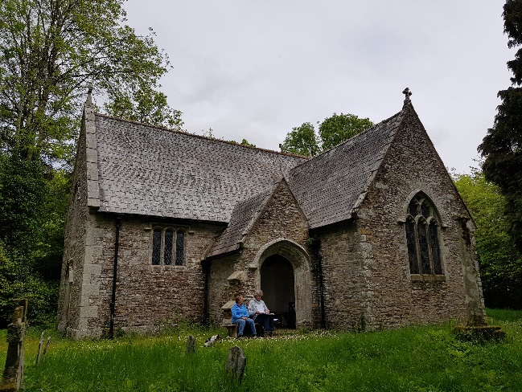
Point A | Brown Long-eared emergence point on the gable end of the southern transept. | 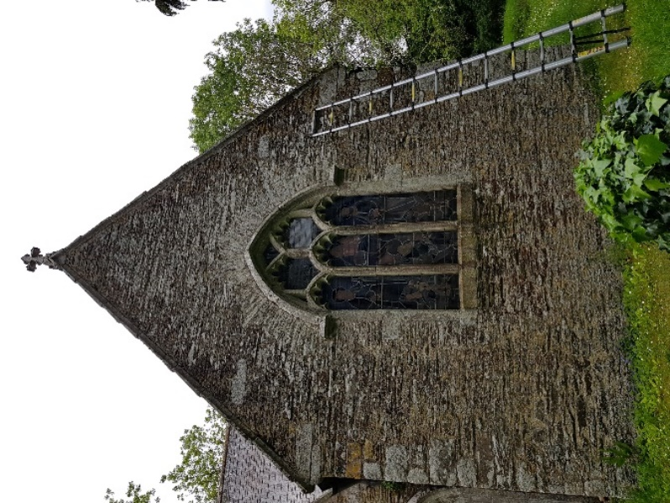
Points B, C, D & E  (from left to right in photo) | External emergence points for Brown Long-eared and pipistrelle bats located along the eastern facing eaves of the southern transept. | 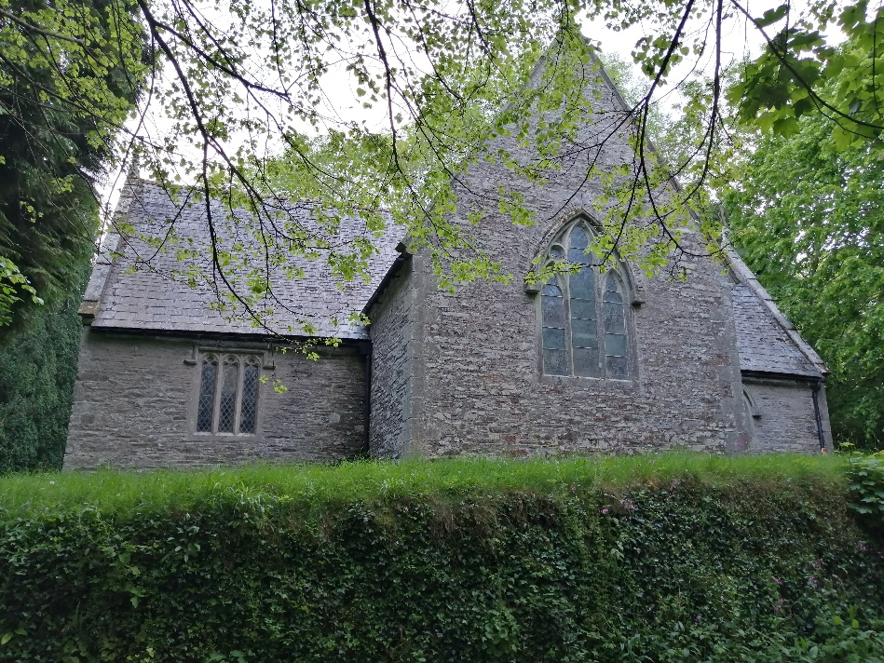
Points F, G & H  (from left to right in photo) | External emergence points for Brown Long-eared and pipistrelle bats located along the southern facing eaves of the chancel. | 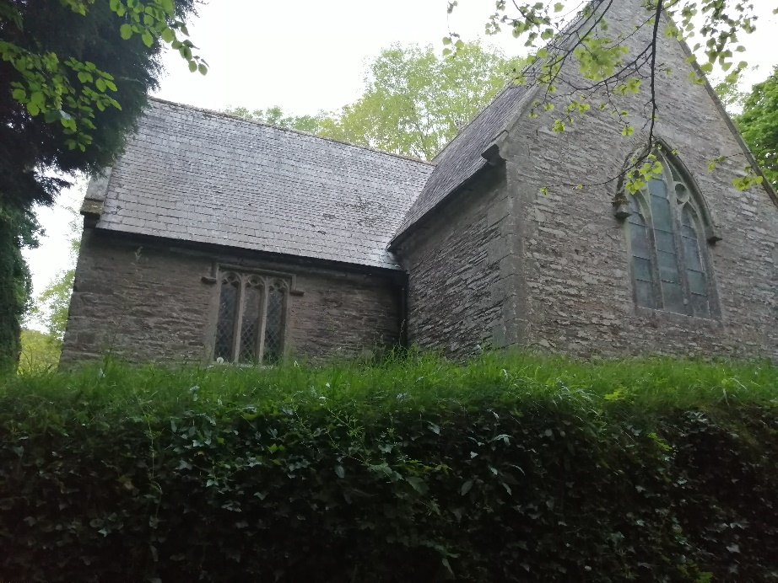
Point I | Soprano Pipistrelle emergence point along the western eaves of the northern transept. | 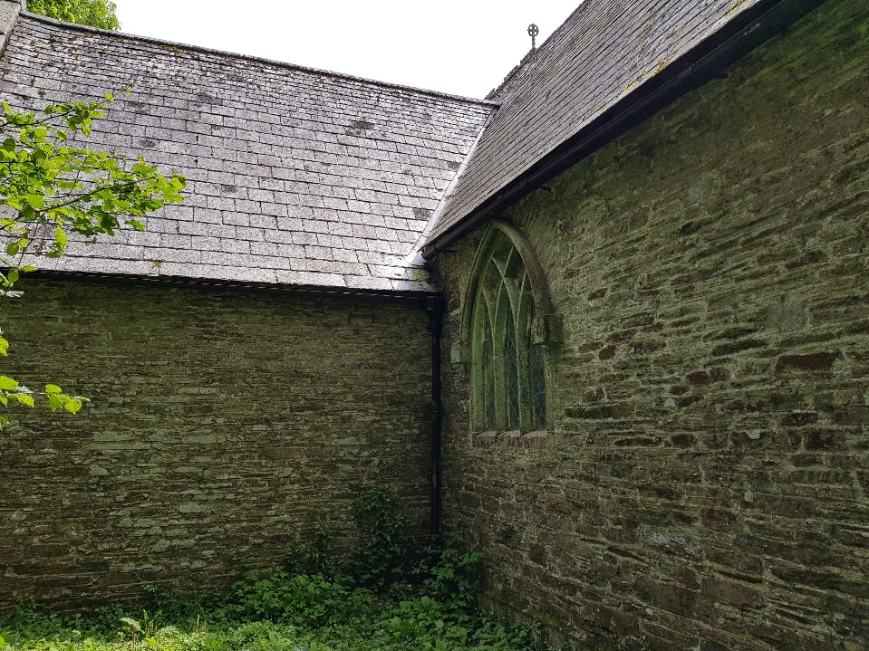
Nave and Chancel | View along the nave to the chancel showing the internal area of the church. | 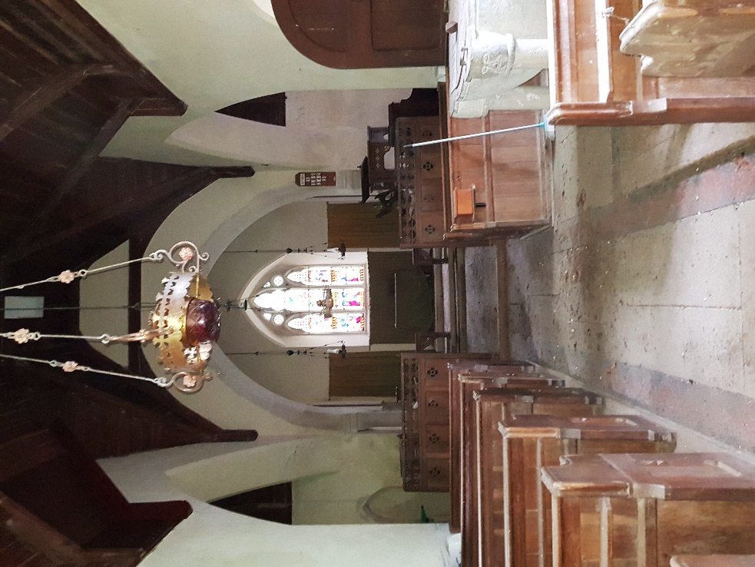
Point J | Gap between the timber roof frame (cross tie/ rafters) and southern gable end wall. Provides one of the main day roosts for Brown Long-eared bats and access to external emergence points. | 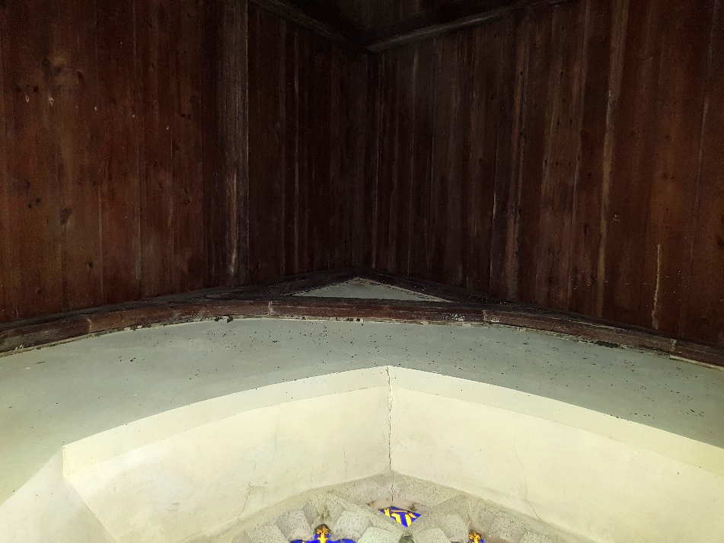
Southern Transept | Photos showing large accumulations of Brown Long-eared droppings on the windowsill (below Point J) in the gable end wall of the southern transept. Accumulations of droppings also occur on furnishings under well-used perches under the wooden panelling within the southern transept. | 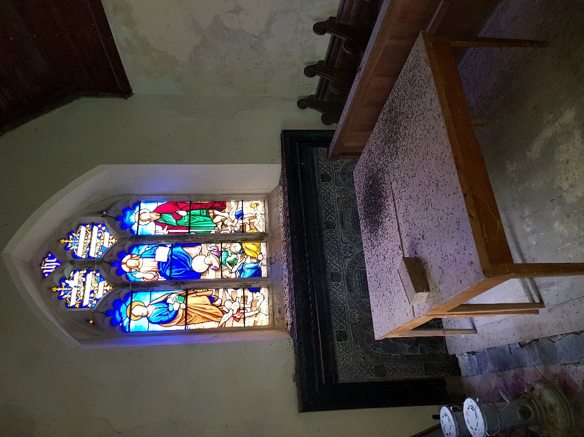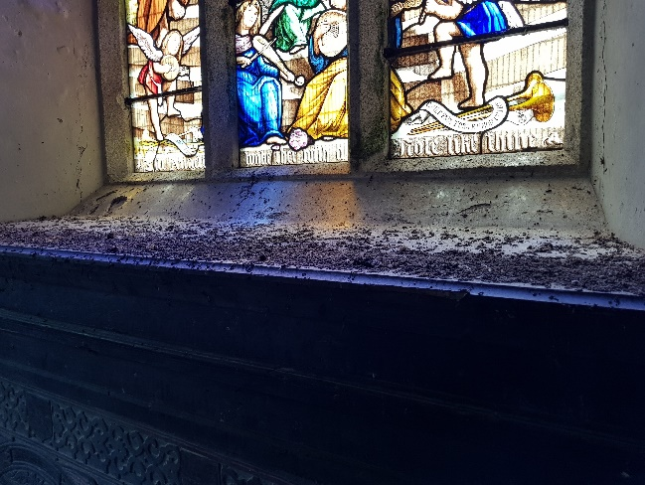
Point K | Potential day roost location for low numbers of Brown Long-eared bats behind panelling above the northern wall of the chancel. | 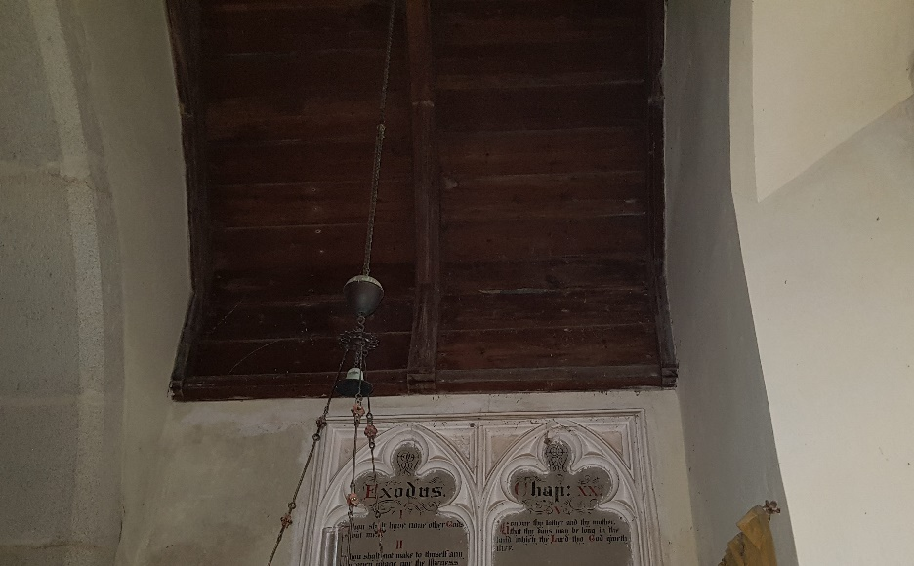
Point L | A key Brown Long-eared day roost location situated behind the ceiling panelling at the apex of the stone arch between the crossing and southern transept. Young bats also regularly perch on the panelling next to the roost access points during the maternity season. | 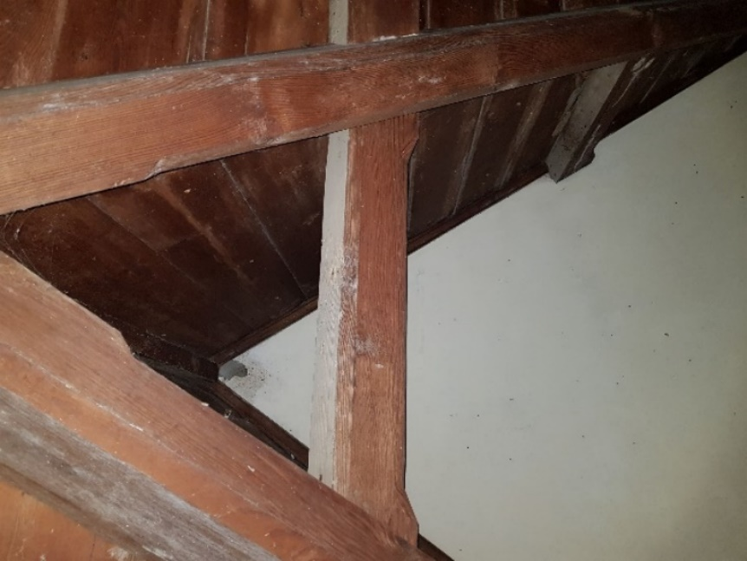
Point M | Gap in wooden panelling along the top of the southern wall of the chancel - the feature most used by Brown Long-eared bats when exiting or re-entering the church. Provides access to external emergence points F & G. | 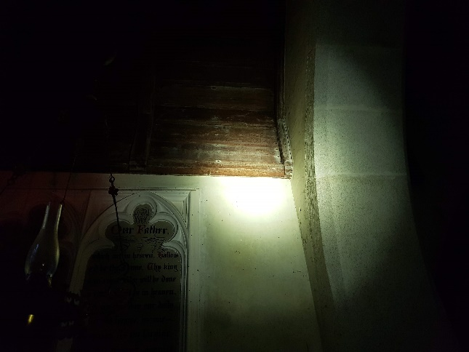
Point N | Located between the rafter and southern gable end wall - one of the key points for Brown Long-eared bats to access the external emergence points when they exit or re-enter the church. | 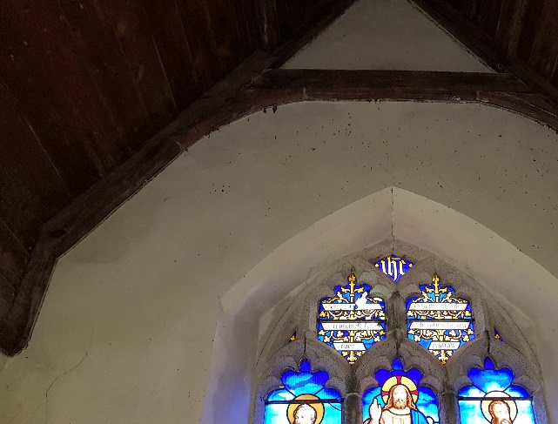
Points P & Q | Situated on the opposite side of the crossing from Point L is another key day roost situated behind the ceiling panelling at the apex of the stone arch between the crossing and northern transept. Entrances to the same roost are believed to be present from both sides of the arch (also at Point Q). A Brown Long-eared bat was recorded perching here during the Light Touch Survey. | 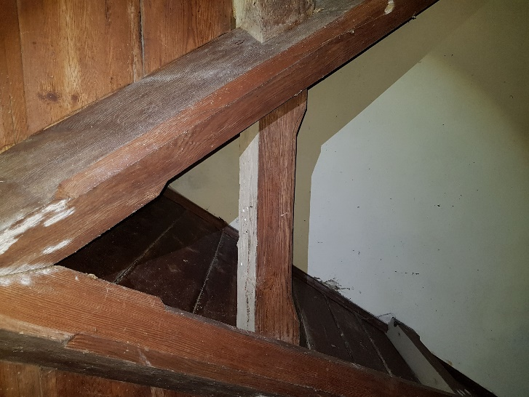
Points L & Q | At points L and Q, roosts above stone arches appear to be accessible from gaps in the wooden panelling at the apex of the ceilings of both the southern and northern transepts, as well as from the crossing. | 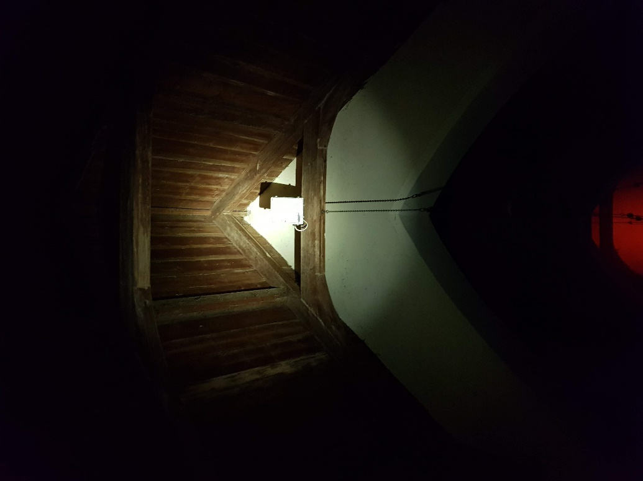
Northern Transept | Large accumulations of droppings on furnishings under well-used perching areas within the chancel/nave. | 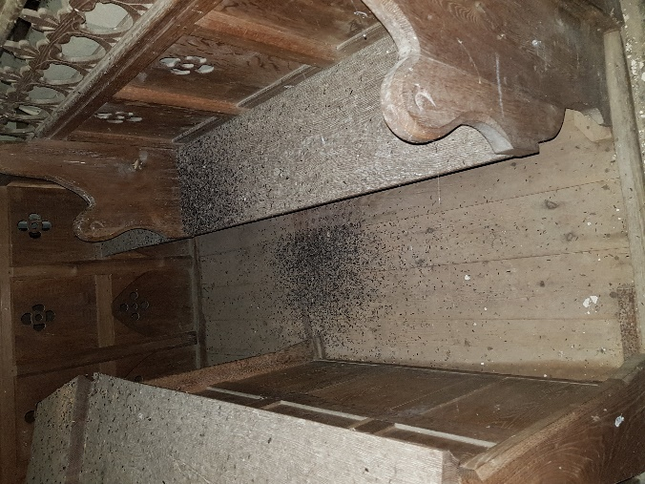
Points  S & T | Gaps in wooden ceiling panelling in the nave, providing access to roosts and unconfirmed access to outside of church via the roof covering or eaves. | 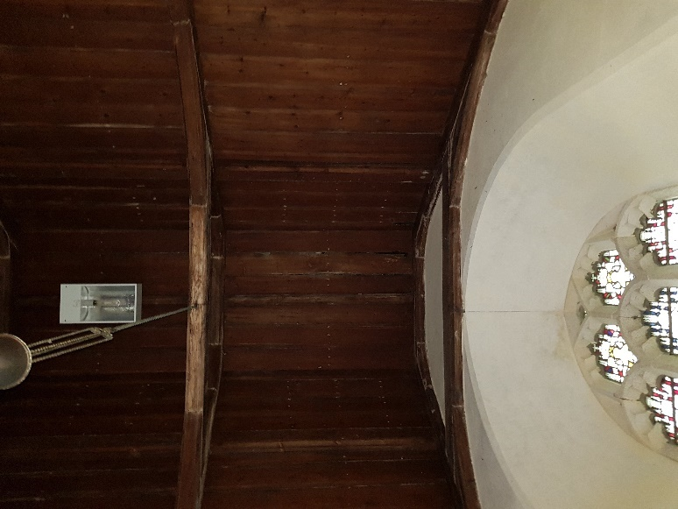
Nave ceiling | View westwards along the ceiling of the nave from the crossing. An enclosed void is present above the flat upper section of the panelling which bats can travel along. | 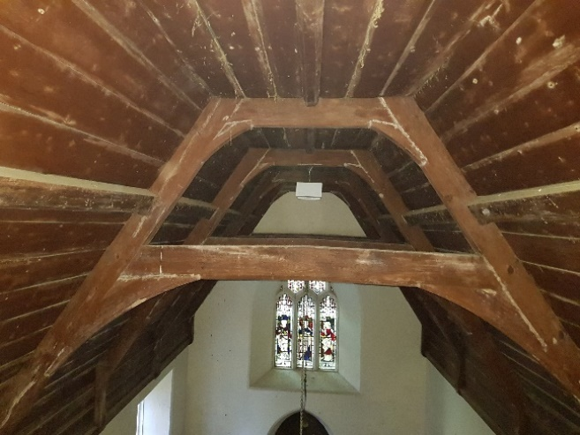
Porch | Porch – the roof of the porch provides a night roost for Greater Horseshoe and possibly Lesser Horseshoe bats, which hang up on the underside of the wooden panelling. | 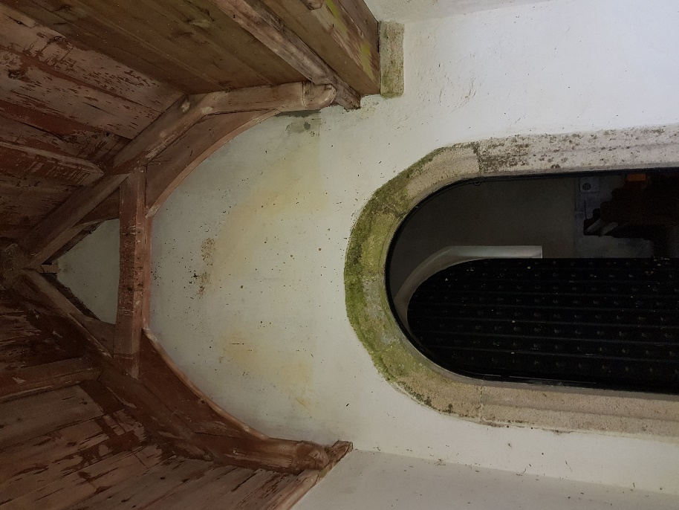

- COPYRIGHT
This report is issued to the client for their sole use and for the intended purpose as stated in the agreement between the client and Tor Ecology Limited or else as set out within this report. This report may not be relied upon by any other party without the express written agreement of Tor Ecology Limited. The use of this report by unauthorised third parties is at their own risk and Tor Ecology Limited accepts no duty of care to any such third party.

As per Bat Conservation Trust Website, The University of Bristol Bat Ecology and Bioacoustics Lab Website, and The People’s Trust for Endangered Species Website.

